|  |
| --- |
| BSeR Domain Analysis Model  Version 1.0 ● Proposed |
| |  | | --- | |  | | Author: | AbdulMalik Shakir | |  |  | |
| |  |  | | --- | --- | | CREATED WITH |  | |

Table of Contents

BSeR Domain Analysis Model 3

**Introduction 3**

Background 3

Project Scope 4

BSeR Use Case Definitions 5

BSeR Use Case Actors 5

Project Approach 6

**BSeR Activity Model 7**

1.0 Service Provider Selection 8

2.0 Service Provider Referral 9

3.0 Referred Patient Intake 10

4.0 Referral Service Provisioning 11

5.0 Service Outcome Reporting 12

**BSeR Information Model 13**

1.0 Patient 16

2.0 Patient Insurance 17

3.0 Provider 18

4.0 Patient Referral 19

5.0 Patient Health Record 20

6.0 Health Record Entry Participant 21

7.0 Patient Health Summary 22

**BSeR Data Elements 23**

# BSeR Domain Analysis Model

## Introduction

This specification is a conceptual model of the functional and information requirements of Bidirectional Services eReferrals (BSeR). BSeR involves the exchange of information between clinical care Electronic Health Records (EHRs) and service systems that reside in community services, lifestyle change, and public health organizations. It also involves the return of information from the services programs to clinical care.

The facilitation of comprehensive health records and the bi-directional connection of EHRs with non-hospital and non-ambulatory service programs is becoming increasingly important. Without common standards for these extra-clinical referrals, they will, individually, make divergent requests to EHR vendors or will not be able to take advantage of electronic information exchange and processable data at all.

**BSeR Data Exchange Standards Development Project**

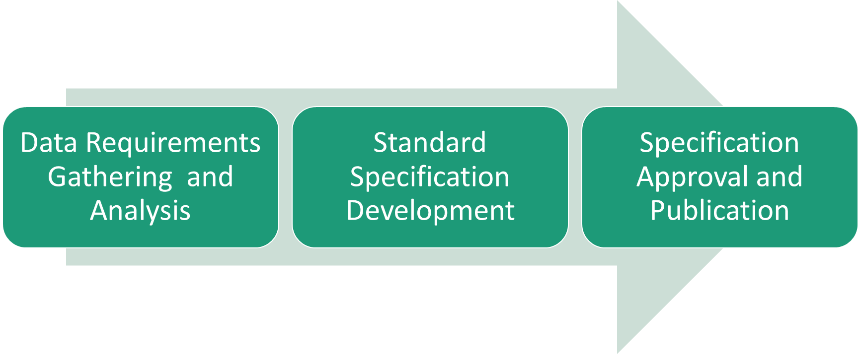

The BSeR Data Exchange Standards Development Project is conducted in three phases. This Domain Analysis Model specification is the primary output from phase 1, data requirements gathering and analysis. Phase 2 will make use of the BSeR DAM to develop implementation guides for using CDA and FHIR as a means of fulfilling the information exchange scenarios expressed in this DAM. The DAM and the CDA and FHIR implementation guides will be balloted as Health Level Seven (HL7) informative and standards for trial (STU) use specifications, respectively.

Health Level Seven defines a Domain Analysis Model (DAM) as:

*“A representation of the static and/or dynamic semantics of a subject-area-of-interest (i.e., domain) in a manner that enables harmonization of the various perspectives of the stakeholders in the domain while also providing the foundations required to create logical platform-independent and implementation platform-dependent models of information artifacts and/or applications whose semantics involve concepts from the domain"*

In keeping with that definition, the BSeR DAM includes both an information viewpoint and a dynamic viewpoint. The information viewpoint provides the static semantics of the data classes and information objects of interest to the BSeR domain. The dynamic viewpoint provides the dynamic semantics of the use cases and process flows of interest to the BSeR domain.

#### Background

The requirements outline in this specification were driven primarily by the needs of the National Center for Chronic Disease Prevention and Health Promotion (NCCDPHP), a division within the Centers for Disease Control and Prevention (CDC). NCCDPHP supports a variety of activities that improve the nation’s health by preventing chronic diseases and their risk factors. Program activities include one or more of our major functions: supporting states’ implementation of public health programs; public health surveillance; translation research; health communication; and developing tools and resources for stakeholders at the national, state, and community levels.

Chronic diseases—such as heart disease, cancer, chronic lung diseases, stroke, and type 2 diabetes—account for most deaths in the United States and globally. They are the major causes of sickness, disability, and health care costs in the nation. Chronic diseases are responsible for 7 in 10 deaths among Americans each year, and the vast majority of health care costs. Chronic diseases are common, costly, and debilitating, and they can often be prevented. By choosing healthy behaviors—like avoiding tobacco, eating and drinking healthy foods and beverages, and getting regular physical activity and enough sleep—people can reduce their chance of getting a chronic disease or improve their health and quality of life if they already have a chronic disease.

The programs operated by the NCCDPHP include:

* Cancer
* Diabetes
* Heart Disease and Stroke
* Nutrition, Physical Activity, and Obesity
* Oral Health
* Preventing Chronic Disease E-Journal
* Population Health
* Reproductive Health
* Smoking and Tobacco Use
* Tribal Resources

Through the programs operated by the NCCDPHP, the Centers for Disease Control and Prevention (CDC) works to prevent chronic diseases and reduce their health and financial costs with an approach that brings together monitoring to understand the problems, communities to work toward solutions and support healthy behaviors, and health care systems to detect problems early and help reduce or eliminate unhealthy behaviors.

NCCDPHP works to prevent chronic diseases and reduce their health and financial costs by working in conjunction with healthcare systems, healthcare payer organizations, and community organizations to work toward solutions and support healthy behaviors. The BSeR Data Exchange Standards Development Project is part of that larger effort.

#### Project Scope

The goal of the BSeR project is to streamline and enhance the efficacy of the exchange of health information between health care systems and community services organizations involved in addressing chronic health conditions by establishing information exchange standards for electronic referrals and referral outcome reporting. Figure 1 - BSeR Use Case Diagram reflects the scope of the BSeR project.

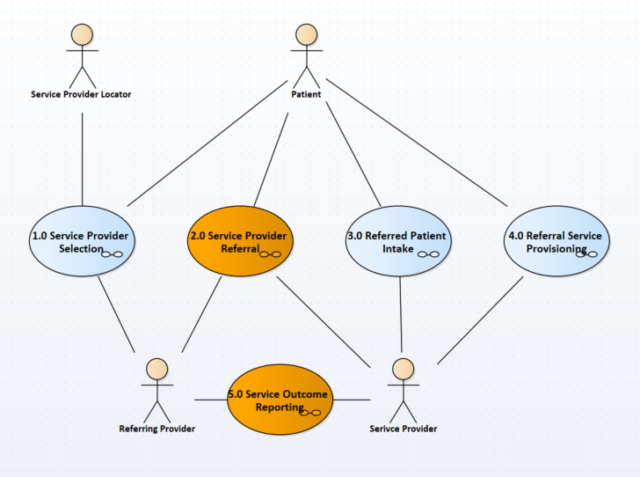

Figure - BSeR Use Case Diagram

The five use cases depicted in Figure 1 - BSeR Use Case Diagram define the scope of the Requirements Gathering and Analysis performed and documented in this Domain Analysis Model Specification. Use Case 2.0 Service Provider Referral and 5.0 Service Outcome Reporting are the scope of the information exchange needs addressed by the HL7 STU BSeR CDA and FHIR Implantation Guides.

#### BSeR Use Case Definitions

The five uses cases of the BSeR DAM are defines as follows:

1. **Service Provider Selection**

In this use case the patient works in conjunction with a service provider locator and referring provider to identify, evaluated, and select a service provider based upon the health needs of the patient, candidate service provider profiles, referring provider recommendations, and patient preferences.

1. **Service Provider Referral**

In this use case the referring provider works in conjunction with the patient, service provider, and referral gatekeepers to assemble relevant clinical history, obtain necessary consents and authorizations, prepare referral instructions, and submit a service referral.

1. **Referred Patient Intake**

In this use case the service provider works in conjunction with the patient, referring provider, and referral gatekeepers to conduct an initial health assessment, confirm patient eligibility, obtain necessary consents and approvals, prepare a plan of treatment, and report the outcome of patient intake to the referring provider.

1. **Referral Service Provisioning**

In this use case the service provider works in conjunction with the patient and referring provider to render the requested services in accordance with the agreed to plan of treatment, record objective and subjective outcomes of services provided along with patient reported outcomes, update the plan of treatment as needed, and report interim and final service provisioning outcomes to the referring provider.

1. **Service Outcome Reporting**

In this use case the service provider engages in preparing feedback for the referring provider regarding the patient intake outcome, referral service provisioning, and final referral outcome. Service outcome reporting practices varies by disease area, service provider capabilities and practice, and referring provider requests. The referral instructions from the referring provider are a major determiner of the reporting practices followed. Service outcome reporting fall into three broad areas: intake, milestone/incidental, and final.

#### BSeR Use Case Actors

The following actors have primary, secondary and contributing roles with regard to their participation in the BSer Use Cases:

1. **Patient** – This is the person with the chronic health condition that needs to be addressed by being referred to a specialist other than their routine healthcare provider.
2. **Service Provider Locator** – This is the person, organization, or system that assists in identifying, evaluating, and selection of a service provider. The service provider locator is the maintainer and provider of service provider profiles used by the patient and referring provider in the evaluation and selection of service providers.
3. **Referring Provider** – This is the medical professional responsible for the overall health and wellbeing of the patient. The referring provider can be an individual clinician, a member of a provider group, or a participant in a large healthcare system. The referring provider is the author of the referral and the recipient of referral service outcome reports.
4. **Service Provider** – This is the individual or organization responsible for providing the services requested by the referring provider on behalf of the patient. The service provider may or may not be a covered entity as defined by the U.S. Department of Health and Human Services (HHS) in the HITECH privacy provisions of the American Recovery and Reinvestment Act. Service providers include licensed and unlicensed professionals accredited to provide lifestyle behavioral health advice and interventions designed to prevent, treat, or reduce the impact of chronic disease conditions.
5. **Referral Gatekeeper** – This is the person, or more typically organization, responsible for adjudicating the appropriateness and authorization worthiness of a referral. Large health systems and other provider organizations use internal referral gatekeeper to ensure that provider referrals are in keeping with the organizations goals and objectives. Service providers use referral gatekeepers as a means of pre-screening and evaluating patients and to assist in obtaining pre-authorizations from payers and other funding sources related to referrals. Payer organizations and funding sources used referral gatekeepers as a means of monitoring utilization, enforcing appropriate use criteria, and to assist in care coordination.
6. **Health Record System** – This is the Electronic Medical Record System (EMR) or Paper Chart used to encode the medical and treatment histories of patients. The BSeR Project assumes that a least one of the participants in the exchange of electronic referrals and referral outcome reports is an EMR. However, the DAM is agnostic as to what form the Health Record System takes. It presumes that in some cases the paper chart may be all that is available, especially within smaller community based service providers. EMRs enhance the capabilities of referring providers by allowing access to evidence-based tools that can use to assist in clinical decision making and through automation streamline provider workflow.

Primary and secondary actors are involved in decision making activities. The primary actor is responsible and accountable for the decisions made. The secondary actor is a major stakeholder in the outcome of decisions made. Contributing actors are information providers. Information provided and decisions made by contributing actors are used as input to the larger decisions made by primary and secondary actors involved in use cases. Table 1 - Actor Roles depicts the roles played by each actor participating in the BSeR use cases.

Table - Actor Roles

| **Use Case** | **Actor** | | | | | |
| --- | --- | --- | --- | --- | --- | --- |
| **Patient** | **Service Provider Locator** | **Referring Provider** | **Service Provider** | **Referral Gatekeeping** | **Health Record System** |
| 1. **Service Provider Selection** | Primary | Contributing | Secondary |  |  | Contributing |
| 1. **Service Provider Referral** | Contributing |  | Primary | Secondary | Contributing | Contributing |
| 1. **Referred Patient Intake** | Secondary |  | Contributing | Primary | Contributing | Contributing |
| 1. **Referral Service Provisioning** | Secondary |  | Contributing | Primary |  | Contributing |
| 1. **Service Outcome Reporting** |  |  | Secondary | Primary |  | Contributing |

#### Project Approach

The requirements gathering and analysis approach taken by the BSeR project was to conduct interviews with CDC chronic disease programs and a representative subset of CDC recognized service providers. Interviews were held with program and service representatives involved with the following health conditions: arthritis, diabetes prevention, early childhood nutrition, hypertension, obesity, and tobacco use cessation. The interviews focused on gaining an understanding of current workflow, especially areas of the workflow that involves inter-enterprise exchange of health information. A potential future-state workflow was used to assist in provoking out-of-the-box thinking and to solicit feedback regarding pain points and process change feasibility.

The BSeR DAM is a record of the findings and analysis stemming from subject matter expert interviews. The DAM presents a generic process flow incorporating and abstracting key aspects of each of disease area specific workflows. Not all aspects of the process flow depicted in the DAM is applicable to all programs. Similarly, the information model portion of the DAM is comprised of a set of shared or common program data and a set of program specific data. Data modeling was used to harmonize information requirements and to express data in the data model using an abstract conceptual framework conducive to reuse across programs and portable to existing HL7 CDA and FHIR standard data structures. Balloting this specification as an informative document is the chosen means of validating it as a specification of requirement for all stakeholders in the BSeR community of users.

## BSeR Activity Model

Figure 2 - BSeR Overall Activity Model Diagram is a high-level process flow of the entire BSeR Domain. The activities included in the model are reflective of the BSeR use cases. The activity model expands upon the use case diagram by including the flow of information from and two use case actors and between use case activities.

The activity model diagram uses standard Unified Modeling Language (UML) notation[1], with a little poetic license to assist in reaching a non-technical audience.

* **Information flows** to and from actors are typically reflected in UML activity diagrams using horizontal or vertical swim lanes to represent the actors. We decided to use the stick figure notation for actor, traditionally reserved for use case diagrams, to represent actors and their related information flows.
* **Data objects** are used to represent the content of information flows to and from activities. The use of data object helps to facilitate the semantic linkage between information flows depicted in the dynamic process viewpoint and information classes depicted in the static information viewpoint of the BSeR DAM.
* **Stereotype guillemets** (<<…>>) include the name of the primary actor for an activity. This helps to provide context for the processes and sub-processes including in the activity diagram and extends the representation of information flows between actors.



Figure - BSeR Overall Activity Model Diagram

The activities contained in Figure 2 - BSeR Overall Activity Model Diagram are further described in subsequent activity model diagrams described in the sections that follow. Each section begins with the activity process flow diagram followed by a description of the processes contained in the diagram. Actors and data objects are reused across diagram boundaries and carry the same descriptive text regardless of diagram placement.

Activities in the BSeR overall activity model are named using gerunds, verbal nouns, as a means of differentiating them from the processes in lower level process flow models that are named using active verbs followed by a noun. The nouns used in activity process names used in the dynamic process viewpoint are consistent with nouns used for information classes in the static information viewpoint.

### 1.0 Service Provider Selection

In this process flow the patient works in conjunction with a service provider locator and referring provider to identify, evaluated, and select a service provider based upon the health needs of the patient, candidate service provider profiles, referring provider recommendations, and patient preferences.



1. 1.0 Service Provider Selection

### Service Provider Referral

In this process flow the referring provider works in conjunction with the patient, service provider, and referral gatekeepers to assemble relevant clinical history, obtain necessary consents and authorizations, prepare referral instructions, and submit a service referral.



1. 2.0 Service Provider Referral

### Referred Patient Intake

In this process flow the service provider works in conjunction with the patient, referring provider, and referral gatekeepers to conduct an initial health assessment, confirm patient eligibility, obtain necessary consents and approvals, prepare a plan of treatment, and report the outcome of patient intake to the referring provider.



1. 3.0 Referred Patient Intake

### 4.0 Referral Service Provisioning

In this process flow the service provider works in conjunction with the patient and referring provider to render the requested services in accordance with the agreed to plan of treatment, record objective and subjective outcomes of services provided along with patient reported outcomes, update the plan of treatment as needed, and report interim and final service provisioning outcomes to the referring provider.



1. 4.0 Referral Service Provisioning

### Service Outcome Reporting

In this process flow the service provider engages in preparing feedback for the referring provider regarding the patient intake outcome, referral service provisioning, and final referral outcome. Service outcome reporting practices varies by disease area, service provider capabilities and practice, and referring provider requests. The referral instructions from the referring provider are a major determiner of the reporting practices followed. Service outcome reporting fall into three broad areas: intake, milestone/incidental, and final.



1. 5.0 Service Outcome Reporting

## BSeR Information Model



1. BSeR Information Model

### BSeR Subject Area Model diagram

Package diagram in package 'BSeR Information Model'



1. BSeR Information Model

**Subject Area Specification**

Each subject area specification includes a class diagram followed by a detailed specification for each class in the subject area. The subject area class diagrams use standard Unified Modeling Language (UML) notation. Classes display their native attributes and inherited attributes. Associative relationships are labeled with a prepositional phrase adorned with an arrow head indicating the direction from which the relationship is defined. Relationships to classes outside the subject area are attached to an instance of the foreign class. Attributes of the foreign class instances are suppressed in the subject area diagram and the foreign class is shaded gray.

**Class Specification**

Each class specification includes

* the class name,
* descriptive text,
* a list of relationship assertions,
* a list of native attributes,
* a list of inherited attributes.

**Relationship Assertions**

Relationship assertions are intended to assist subject matter experts that may not be well-versed in UML notation. They are written using the following sentence pattern:

**Each** <source className> **{always | sometime}** <relationship predicate> **{one | one or more}** <target className>**.**

**Attribute Specification**

Each attribute specification includes descriptive text, a datatype designation, and a list of cross-references to relevant data collection form locations.

**Datatype Designation**

The datatype designations are a subset drawn from the [HL7 Version 3 Standard: Data Types - Abstract Specification, Release 2](http://www.hl7.org/implement/standards/product_brief.cfm?product_id=264).

The subset of datatypes used in this specification include:

* AD - Postal Address
* BL - Boolean
* CD - Concept Descriptor
* ED - Encapsulated Data
* II - Instance Identifier
* INT - Integer
* PN - Person Name
* PQ - Physical Quantity
* ST - String
* TS - Point in Time Specification

The concept descriptor datatype (CD) is used in this specification to represent concepts that “may” be coded. In some cases, the code for the concept may yet to have been assigned and in such a case the original text portion of the CD datatype would contain a free-text expression of the concept.

### 1.0 Patient

| LINKS TO OTHER PACKAGES | |
| --- | --- |
| Dependency from '5.0 Patient Health Record' Package to '1.0 Patient' Package | Direction: Source -> Destination |
| Dependency from '2.0 Patient Insurance' Package to '1.0 Patient' Package | Direction: Source -> Destination |
| Dependency from '4.0 Patient Referral' Package to '1.0 Patient' Package | Direction: Source -> Destination |



1. Patient

### 2.0 Patient Insurance

Package in package 'BSeR Information Model'

| LINKS TO OTHER PACKAGES | |
| --- | --- |
| Dependency from '2.0 Patient Insurance' Package to '1.0 Patient' Package | Direction: Source -> Destination |



1. Patient Insurance

### 3.0 Provider

Package in package 'BSeR Information Model'

| LINKS TO OTHER PACKAGES | |
| --- | --- |
| Dependency from '5.0 Patient Health Record' Package to '3.0 Provider' Package | Direction: Source -> Destination |
| Dependency from '4.0 Patient Referral' Package to '3.0 Provider' Package | Direction: Source -> Destination |



1. Provider

### 4.0 Patient Referral

Package in package 'BSeR Information Model'

| LINKS TO OTHER PACKAGES | |
| --- | --- |
| Dependency from '4.0 Patient Referral' Package to '1.0 Patient' Package | Direction: Source -> Destination |
| Dependency from '4.0 Patient Referral' Package to '3.0 Provider' Package | Direction: Source -> Destination |
| Dependency from '7.0 Patient Health Summary' Package to '4.0 Patient Referral' Package | Direction: Source -> Destination |



1. Patient Referral

### 5.0 Patient Health Record

| LINKS TO OTHER PACKAGES | |
| --- | --- |
| Dependency from '5.0 Patient Health Record' Package to '1.0 Patient' Package | Direction: Source -> Destination |
| Dependency from '5.0 Patient Health Record' Package to '3.0 Provider' Package | Direction: Source -> Destination |
| Dependency from '6.0 Health Record Entry Participant' Package to '5.0 Patient Health Record' Package | Direction: Source -> Destination |
| Dependency from '7.0 Patient Health Summary' Package to '5.0 Patient Health Record' Package | Direction: Source -> Destination |



1. Patient Health Record

### 6.0 Health Record Entry Participant

Package in package 'BSeR Information Model'

| LINKS TO OTHER PACKAGES | |
| --- | --- |
| Dependency from '6.0 Health Record Entry Participant' Package to '5.0 Patient Health Record' Package | Direction: Source -> Destination |



1. 6.0 Health Record Entry Participant

### 7.0 Patient Health Summary

Package in package 'BSeR Information Model'

| LINKS TO OTHER PACKAGES | |
| --- | --- |
| Dependency from '7.0 Patient Health Summary' Package to '5.0 Patient Health Record' Package | Direction: Source -> Destination |
| Dependency from '7.0 Patient Health Summary' Package to '4.0 Patient Referral' Package | Direction: Source -> Destination |



1. 7.0 Patient Health Summary

## BSeR Data Elements

Referral Data Elements

* Allergies (Y/N)
* Baby's Birthdate
* Baby's Height/Length (cm)
* Baby's Name
* Baby's Sex
* Baby's Weight (kgs.)
* bestDayToCall
* bestTimeToCall
* BMI (cm/KG)
* Date last BP taken
* Diagnosis code ICD10 (6)
* Diagnosis code text (6)
* HA1c date taken
* HA1c done (Y/N)
* HA1c percent
* Height (inches)
* identifier
* Is Baby Latching
* Last BP taken
* Last taken BP diastolic
* Last taken BP systolic
* Last taken BP systolic/diastolic
* leaveMessageIndicator
* Medication dose
* Medication frequency
* Medication History
* Medication name
* Mom's BMI (cm/KG)
* Mom's Height (inches)
* Mom's Main Concerns
* Mom's Weight (lbs.)
* NicotineReplacementTherapyAuthorization
* Nipple shield Use
* referralDateTime
* referralNote
* referralReason
* referralType
* smokingStatus
* Weight (lbs.)

Feedback Data Elements

* % of sessions Attended
* activityStatus
* activityStatusReason
* Appropriate use of medications
* BMI (cm/KG)
* BP Diastolic
* BP Systolic
* BP systolic/diastolic
* breastfeeding challenges/symptoms
* cessationMedications
* cessationMedicationUseIndicator
* feedbackReportDate
* feedbackReportNote
* Healthy eating
* Height (inches)
* improving strength, flexibility, and endurance
* lactation support
* Medications
* Pain Management
* pain, fatigue, frustration and isolation
* quitDateSetIndicator
* referralIdentifier
* referralStatus
* referralType
* sessionsAttendedQuantity
* sessionType
* tobaccoFreeDuration
* Tongue-tie and lip-tie assessment
* Weight (lbs.)

**BSeR Data Element to Information Exchange Specifications Mapping**



1. Fowler, Martin. UML Distilled: A Brief Guide to the Standard Object Modeling Language (3rd ed.). Addison-Wesley. ISBN 0-321-19368-7.